RETURN OF RESULTS INFORMATION SHEET
Template instructions (delete after filling in template):
This sheet is intended to support the decision and discussion around a participants’ choice to receive results. It should be adapted and/or adopted for the individual study and the choices that the participant may have.
The <red type in brackets> below should be changed to reflect the plan of the study and the types of results that a participant has the option to receive below.
Add and explain as many different types of results as necessary.
Record participants’ choices in your study documents and/or the informed consent form. In addition, check the boxes on this form for participants to take home as a reminder of their decisions.
<Insert study name>
<Insert PI/Study contact>

What is this sheet?
This sheet describes the types of research results that you <may choose to/will/can> receive by participating in <insert plain language study title here>.
You can choose whether or not to receive these results.
Note, however, that we must return urgent results that require medical attention with you and/or your doctor. You do not have a choice with respect to urgent results. We will explain the reasons why below.
Can I change my mind about getting my results?
Yes, if you decided to receive results and you change your mind later, you can contact us at any time by: <insert mode of contact>
No matter what you decide, we will give you another chance to choose whether to receive results on: <insert pre-specified review time if applicable>
Result 1: Urgent results that require medical attention
☒ Any result like this must be returned
Description: If an urgent result arises, we must return it to you in order for you to receive additional evaluation and/or care. Examples from this study could be if: <<insert any plausible example from your type of study, such as: A routine scan for this study found a tumor>>.
We might also need to share this information with your doctor or healthcare provider. Additional evaluation and/or care unrelated to this research, if you need it, will not be paid for by the study. You will need to follow up with your doctor.
Who would return this to me and how? | When would it be returned to me?
<explain your return plan for urgent results>  Example: If this situation occurs, the principal investigator for this study will contact you by phone.  The investigator would also contact your healthcare provider by phone to tell them about the situation/result. | <explain your return plan for urgent results>  Example: This would happen as soon as possible/as soon as the result is confirmed by another test/etc.

Result 2: What you received in this study (also known as study arm assignment)
☐ If this box is checked that means you chose to receive this result
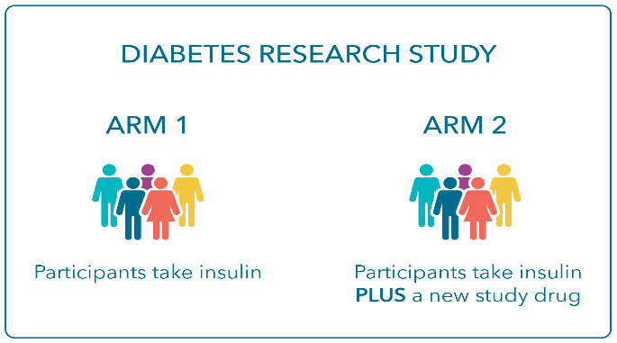
Description: We will tell you if you received the study treatment <name/describe treatment> or the <standard of care/placebo> <name/describe placebo>.
A study arm is a group of participants in a research study who all receive the same study treatment. Knowing what you received in a study could help you make decisions with your doctor about which treatments you should use or try in the future.
Example of a study with two arms
Who would return this to me and how? | When would it be returned?
<explain your return plan for this result>  Example: You will receive a letter in the mail that tells you what treatment you received during this study | <explain your return plan for this result>  Example: This letter will be mailed after the study has ended for all participants, which could be many <months/years> after the study has ended for you personally.

Result 3: <Other Result or Results>
☐ If this box is checked that means you chose to receive this result
Description: <describe other result or results, for example: routine blood pressure and weight measurements taken at study visits>
Who would return this to me and how? | When would it be returned?
<explain your return plan for this result>  Example: These results will be uploaded into your study portal, and you will receive an email when they are available. You will have to log into the study portal to view them. | <explain your return plan for this result>  Example: These will usually be available 24 hours after each study visit.

Result 4: < Other Result or Results>
☐ If this box is checked that means you chose to receive this result
Example: <describe other result or results, for example: blood glucose readings or lab results>
Who would return this to me and how? | When would it be returned?
<explain your return plan for this result>  Example: You will receive a letter in the mail that tells you what your cholesterol was at each study visit. | <explain your return plan for this result>  Example: This letter will be mailed after the study has ended for all participants, which could be many months after the study has ended for you personally.
<Add additional results as needed>

